9.37: a) For each mass, the square of the distance from the axis is 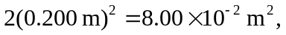and the moment of inertia is b) Each sphere is 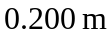 from the axis, so the moment of inertia is
- The two masses through which the axis passes do not contribute to the moment of inertia. 